Changes to be done
COMPANY MASTER
- Registering company details such as
# Type of Company (Proprietorship / Partnership / LLP / Limited /Private Limited / HUF etc.)
# company name
# Registered address (Line 1, Line 2, City, Pin code, State, Country)
# Warehouse address (Line 1, Line 2, City, Pin code, State, Country)
# PAN No., TAN no., GST No., CIN no., Etc.
# Telephone no.
# Email id
# website

Financial Year Management (Year wise)

Rights management (User control and access control)

EMPLOYEE MASTER
# Department (Purchase, Sales, Quality, Warehouse, Accounts)
# Name of the Employee
# Designation of Employee
# Email id
# Mobile no.
# Telephone no.

CUSTOMER MASTER
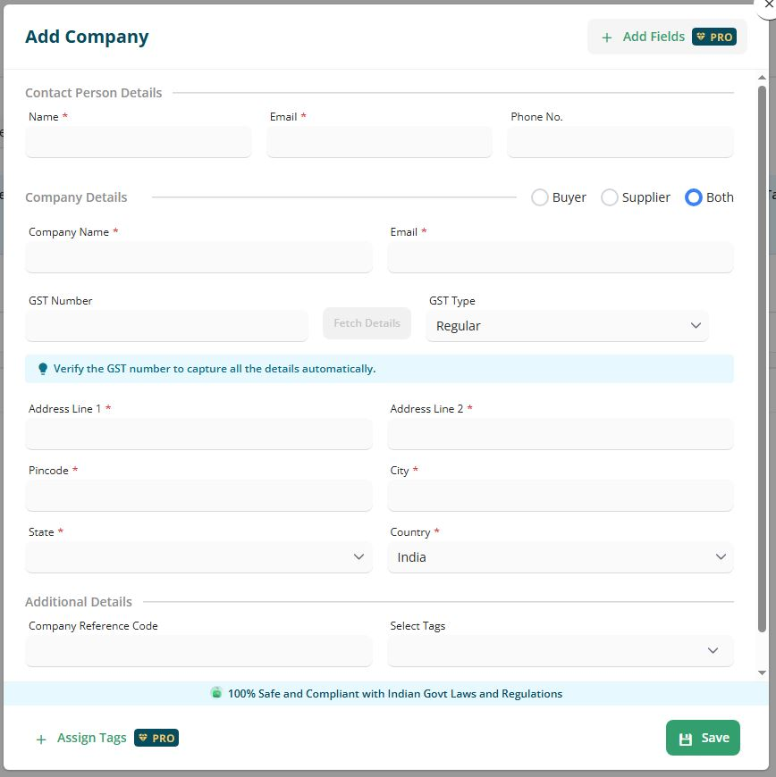

# Add filed to add - Opening balance of the customer to be maintained
# Terms and conditions selection client wise, so that whenever we prepare quotation for them, the default Terms and conditions shows in the quotation.

In Customer’s master, there should be additional Dispatch Address fields, so details of dispatch location can be registered, as there same will be helpful in preparing the invoice (eg. Buyer & Consignee details, Place of Supply)

BUYER MASTER
Buyer Master to be developed to connect multiple buyer to a single client/Customer

In buyer master, following data need to be captured
# Selecting the Name of the client/Customer to which buyer connected, if already register in system.
# Name of the Buyer
# Designation of Buyer
# Email id
# Mobile no.
# Telephone no.

(This buyer master can also help to generate report that to which buyer we have given the no. of quotation and which are converted to order, so to identify which buyer gives most business company wise.)

Similarly, Supplier/Vendor Master flow to be created based on client master & flow
# to issue inquiry to them against a order received from client.
# Issue purchase order to them.
# Create inward GRN.

PRODUCT MASTER

As we have mentioned we require 2 type of quotation
# Standard Quotation
# Non Standard Quotation

# Standard Quotation
- Quotation for Pipe, fittings & Flanges which can be selected from drop down by creating master
# We can share masters with you in excel which can be used to pull data in system.
# Quotation format already shared with you

# Non Standard Quotation
- Quotation for other items, which does not fall in Standard quotation gets created in this, where we copy client requirement and paste of type in the description field.
# Quotation format already shared with you

So the flow should be such that when you plan to prepare a quotation, there should be a selection to prepare STANDARD QUOTATION or NON STANDARD QUOTATION

# Each item should have a Material code / Item code (it is a combination of Alfa numeric which links to the product/item we are offering to client. This will give us insight and help us in identify the product quoted/sold to client in past at what pricing level, whether order received or not. For product for which we do not have Material code / Item code, we should be able to Auto allot our Material code / Item code.

UNIT MASTER
Kg., Piece, No., Meter, Feet, MM, Inch, etc.

